AS Level Chemistry Nomenclature Practice Sheet (Cambridge)

Section A: Basic Naming
- Provide the IUPAC names for the following compounds:
  - a. CH₃CH₂CH₂CH₃
  - b. CH₃CH₂CH(OH)CH₃
  - c. CH₃CH₂COOH
  - d. CH₃CH₂CH₂CH₂Br
  - e. (CH₃)₂C=CHCH₃
- Draw the structures for the following IUPAC names:
  - a. 2-methylbutane
  - b. 3-chloropentanoic acid
  - c. 2,2-dimethylpropane
  - d. 3-methyl-2-butanone
  - e. Propyl ethanoate
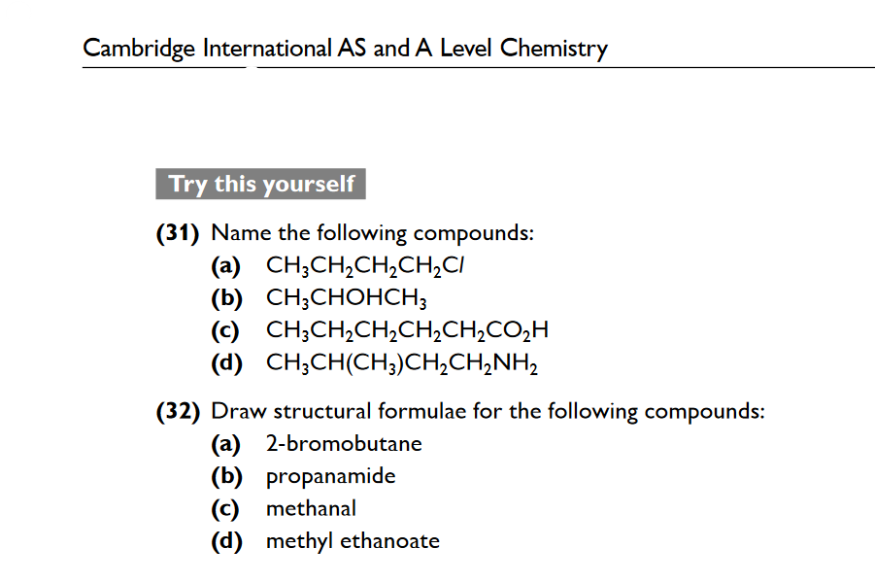

Section B: Functional Groups Identification
- Identify the functional group in each compound:
  - a. CH₃CH₂CHO
  - b. CH₃CH₂COCH₃
  - c. CH₃CH₂CH₂OH
  - d. CH₃CH₂CH₂COOH
  - e. CH₃OCH₃
- Classify each compound as either an alkane, alkene, alcohol, ketone, aldehyde, carboxylic acid, or ester:
  - a. C₂H₆
  - b. C₃H₆O (with the functional group on the second carbon)
  - c. CH₃COOCH₃
  - d. C₄H₆
  - e. CH₃CH=CH₂

Section C: Isomerism
- Identify whether each pair of compounds are structural isomers or the same compound:
  - a. CH₃CH₂CH₂CH₃ and (CH₃)₂CHCH₃
  - b. CH₃CH₂OH and CH₃OCH₃
  - c. CH₃CH₂CH₂CH₂OH and CH₃CH(OH)CH₂CH₃
  - d. CH₃CH₂CH₂COOH and CH₃COOCH₃
  - e. CH₃CH=CH₂ and CH₂=CHCH₃
- Draw all possible structural isomers of C₄H₈ and provide their IUPAC names.

Section D: Application and Analysis’’
- Naming Complex Structures:
  - Write the IUPAC name for the following complex organic compounds:
    - a. (CH₃)₂C=CHCH₂CH₃
    - b. CH₃CH₂CH(CH₃)CH₂CH₂CH₂OH
    - c. CH₃CH=CHCH₂COOH
    - d. CH₃COCH₂CH₂CH₃
    - e. (CH₃)₂CHCH₂CH(CH₃)CH₃
- Structure Identification from Names:
  - Draw the structures for the following names:
    - a. 4-methylpent-2-ene
    - b. 2-chloro-3-methylbutane
    - c. 3-ethyl-2-methylpentane
    - d. 2-methyl-2-pentanol
    - e. Ethyl 2-methylpropanoate

Section E: Mixed Review
- Identify Errors in Naming:
  - Examine the names below and correct any mistakes:
    - a. 2-methyl-4-butane
    - b. 3-ethylpentane
    - c. 2,2-dimethylbutane
    - d. 1-propyl-2-butene
    - e. 3-methyl-3-pentanol
- Multiple Choice: Choose the correct IUPAC name:
  - Which is the correct IUPAC name for the compound CH₃CH₂C(CH₃)₂CH₂CH₃?
    - a. 3-methyl-2-pentane
    - b. 2,2-dimethylpentane
    - c. 2-methyl-3-pentane
    - d. 3,3-dimethylpentane
For AS level Chemistry (Cambridge International 9701 syllabus), organic chemistry covers several key topics. Here are some commonly tested areas in past papers:
- Nomenclature:
  - Naming organic compounds based on functional groups.
  - Identifying compounds with correct IUPAC names.
- Isomerism:
  - Structural isomerism (chain, position, and functional group isomerism).
  - Stereoisomerism, including geometric (cis-trans) isomerism and understanding chiral centres.
- Functional Groups:
  - Recognizing and naming functional groups such as alcohols, carboxylic acids, alkanes, alkenes, ketones, aldehydes, etc.
  - Reactions specific to functional groups, like oxidation of alcohols and addition reactions of alkenes.
- Reactions of Organic Compounds:
  - Basic reactions, such as substitution, addition, and elimination.
  - Mechanisms are usually simplified for AS level but understanding types of reactions is essential.
- Hydrocarbons:
  - Properties and reactions of alkanes, alkenes, and arenes.
  - Understanding concepts like combustion, hydrogenation, and cracking.
practice past paper questions directly related to organic chemistry concepts covered in AS level.

For the 9701 Cambridge International AS and A Level Chemistry syllabus, organic chemistry is a significant topic. The questions in past papers typically cover areas such as:
- Functional Groups and Nomenclature
  - Recognizing and naming functional groups like alkanes, alkenes, alkynes, alcohols, ethers, carboxylic acids, esters, aldehydes, ketones, amines, amides, and halides.
  - Drawing and interpreting structural, displayed, and skeletal formulas.
- Isomerism
  - Structural isomers and stereoisomers (E/Z isomerism and optical isomerism).
  - Understanding chirality and identifying chiral centers.
- Reaction Mechanisms
  - Electrophilic addition reactions (common with alkenes).
  - Nucleophilic substitution reactions, particularly with halogenoalkanes.
  - Elimination reactions leading to the formation of alkenes.
  - Free radical substitution, mainly for alkanes.
  - Understanding SN1 and SN2 mechanisms.
- Alkanes, Alkenes, and Alkynes
  - Properties, combustion, and types of reactions, such as addition and substitution.
  - Markovnikov's rule in addition reactions.
- Aromatic Compounds
  - Benzene and its structure (delocalized π-electrons).
  - Electrophilic substitution reactions (nitration, sulfonation, halogenation, alkylation, and acylation).
- Alcohols and Phenols
  - Classification (primary, secondary, tertiary).
  - Oxidation reactions (e.g., conversion of primary alcohols to aldehydes and carboxylic acids).
  - Esterification reactions and dehydration.
- Carbonyl Compounds
Aldehydes and ketones, their properties, and reduction/oxidation reactions.
Nucleophilic addition reactions (with reagents like HCN).
      - . Carboxylic Acids and Derivatives
  - Properties and reactions, such as esterification.
  - Hydrolysis of esters and amides.
9 Amines, Amides, and Nitrogen Compounds
  - Basicity of amines, preparation methods, and reactions.
  - Formation and reactions of amides, including condensation and hydrolysis.
    - Polymers
- Addition polymerization vs. condensation polymerization.
- Understanding common polymers and their monomer units.
These topics often appear in a variety of question formats, including structured questions, multiple-choice, and problem-solving sections that involve reaction mechanisms, synthetic pathways, or identifying compounds based on their reactions

